HIDE THE PROJECT FROM TASKBAR

SHOW THE PROJECT IN SYSTEM TRAY

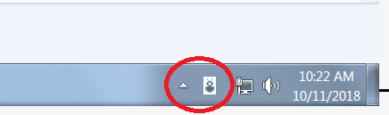

From ToolBox drop down NotifyIcon

In Form Properties include Icon image, type ICO

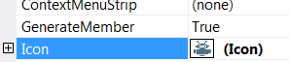

Events

private void Form1_Resize(object sender, EventArgs e)

{

this.Hide();

NotifyIcon.Visible = true;

NotifyIcon.Text = "Chat2Verint";

NotifyIcon.BalloonTipText = "";

//NotifyIcon.ShowBalloonTip(5000, _trayText, _trayText, ToolTipIcon.Info);

}

Load Event

this.WindowState = FormWindowState.Minimized;